**CF 2.15 SP DS e-Filing**

**Performance Test Approach**

**Version 1.00 – 11/09/2013**

|  |  |  |  |
| --- | --- | --- | --- |
| **File** | OHIM-ITOIS-CF2.15 SP DS e-Filing-PTA-v1.00-EN.docx | | |
| **Author** | QC | QC Team | Quality Analyst |
| **To** | NG | Nikos Giannelos | Project Manager |
|  | XXh | Xavier Xheneumont | Quality Manager |

**Version history**

| Version | Date | Author | Contributors | Change Summary |
| --- | --- | --- | --- | --- |
| 1.0 | 11/09/2013 | QC |  | Document creation |

**References**

| Ref. | Version | Date | File Name |
| --- | --- | --- | --- |
| R1 | 2.03 | 27/04/2012 | [CF 2 15 SP DS e-Filing global FAD_v2.03.docx](http://admindocs/alfresco/n/showDocDetails/workspace:/SpacesStore/73e4b885-19e2-4853-9421-8a7f7e82b90e) |

Table of Contents

1 Introduction 4

2 Test Objectives 5

3 Scope of Testing 6

4 Performance Test Approach 7

4.1 Test Strategy 7

4.2 Workload Profiles 7

4.3 Volumetrics 8

4.4 Performance/Response Verification 10

4.5 Test Data 10

4.6 Acceptance Criteria 10

5 Entry/Exit Criteria 11

5.1 Entry Criteria 11

5.2 Exit Criteria 11

6 Test Environment and Monitoring 12

7 Risks 13

List of Figures

Figure 1 – Load Test Configuration 9

List of Tables

Table 1 - Testing Activities in and out of Scope 6

Table 2 - Virtual User Distribution 8

Table 3 - Load Test - Virtual User Distribution 9

Table 4 - Test Input Data 10

Table 5 - Data Input of the csv files 10

Table 6 - VMs Technical Specifications 12

# Introduction

The purpose of this document is to define a first approach to the Performance Testing of CF 2.15 SP DS e-Filing.

SP DS e-Filing will allow users to submit their applications for the registration of designs electronically. More precisely, users will be able to provide data related to the SP DS e-Filing application, such as:

* Person details (Applicants, Representatives, Designer)
* Designs (Number of designs, Images (Views), etc.)
* Claims (Priority claim, Divisional application, etc.)
* Supplementary information, etc.

SP DS e-Filing will further support the users in submitting their applications through advanced functionality, such as online and real-time validation of the data entered, uploading and previewing of high quality digital images, integration with online payment systems, etc.

Performance testing provides confidence in the stability and scalability of the whole system. It provides an opportunity to optimize the application and the infrastructure to maximise the throughput from the system. It aids in capacity planning and augmenting operational procedures to suit the system limitations.

This approach document has been based on conversations with various project staff and requires approval.

# Test Objectives

As the application will be installed in the National Offices production environment for the first time, it is essential to make sure that the application will be stable and usable in production.

According to Non Functional Requirements section in FAD [R1] performance testing will be focused in the following goals:

* Verify the SP DS e-Filing system installation and configuration is stable and no issue of performance is found regarding the implementation of the application.
* Check processes and response times for the transactions described at CF215 SP DS e-Filing [R1] of the application.

# Scope of Testing

The following table shows the testing activities in scope and out of scope of QC for this testing phase:

|  |  |
| --- | --- |
| Tasks | In Scope |
| Test Scenario Design | ✓ |
| Test Data Preparation | ✓ |
| JMeter script development | ✓ |
| Vertical Test Execution | ✓ |
| Load Test Execution | 🗶 |
| Stress Test Execution | 🗶 |
| Stability Test Execution | 🗶 |
| Scalability Test Execution | 🗶 |
| Test Environment Monitoring | ✓ |
| Results analysis | ✓ |
| Performance Test Report delivery | ✓ |

Table 1 - Testing Activities in and out of Scope

# Performance Test Approach

## Test Strategy

The test strategy for this project consists in the simulation of real users using JMeter scripts.

Apache JMeteris an open source software designed to perform load testing and measure performance.

According to the objectives of this testing phase the following test scenarios must be executed:

**Vertical Test**: In order to check that no issue of performance is found regarding the implementation of the application.

## Workload Profiles

The following profiles have been composed according to the CF 2 15 SP DS e-Filing global FAD_v2.03 [R1] document. Each Profile will perform several actions mentioned at document and JMeter will be used for that purpose.

The following lines show the actions executed by each profile which each have a delay of 5 seconds between them.

**Profile 1 – Fill in application (Wizard)**

**Delay between steps:** 5 seconds

**Navigation:**

* Access to DS e-Filing wizard
* Fill in a reference
* Add two designs manually and add four views per design.
* Click “Next”
* No deferment.
* No claims*.*
* Click “Next”
* Import an applicant.
* Import a representative.
* Click “Next”
* Import a designer
* Click “Next”
* Provide supplementary information in two attachment files
* Provide textual signature
* Indicate the entitlement right to apply design is officiary and upload an attachment
* Click pay online and submit application

**Profile 2 – Modify information imported (OneForm)**

**Delay between steps:** 5 seconds

**Navigation:**

* Access to DS e-Filing OneForm
* Fill in a reference
* Import a registered design and add multiple views to the imported design
* Modify the application data imported
* Provide any missing mandatory information
* Submit application

## Volumetrics

This chapter describes how the virtual users will be executed during the tests.

### Assumptions

According to CF 2 15 SP DS e-Filing FAD v2.03 [R1] and conversations with the project staff the application will be installed in an unknown architecture by each Office. Therefore, this performance test will check the process of the application works well.

### Virtual User Distribution

The following table represents the virtual user distribution for the Load Test Configurations.

Test configuration will be based on the assumptions mentioned above. The following table shows the scenario:

| Test Scenario | Max Users | Full Load Duration |
| --- | --- | --- |
| **Vertical Test** | 2 | 1h |

Table 2 - Virtual User Distribution

More details can be found in the following sections.

#### Vertical Test

In order to check if the system behaves properly at a given level of load, the following configuration has been designed:

The following table shows the configuration proposed:

| Workload Profile | Max Users | Total Duration |
| --- | --- | --- |
| **Profile 1 – Fill in application (Wizard)** | 1 | 1h |
| **Profile 2 - Modify information imported (OneForm)** | 1 | 1h |
| **Total** | 2 | 1h |

Table 3 - Load Test - Virtual User Distribution

The following picture shows how users are getting into the system over time.

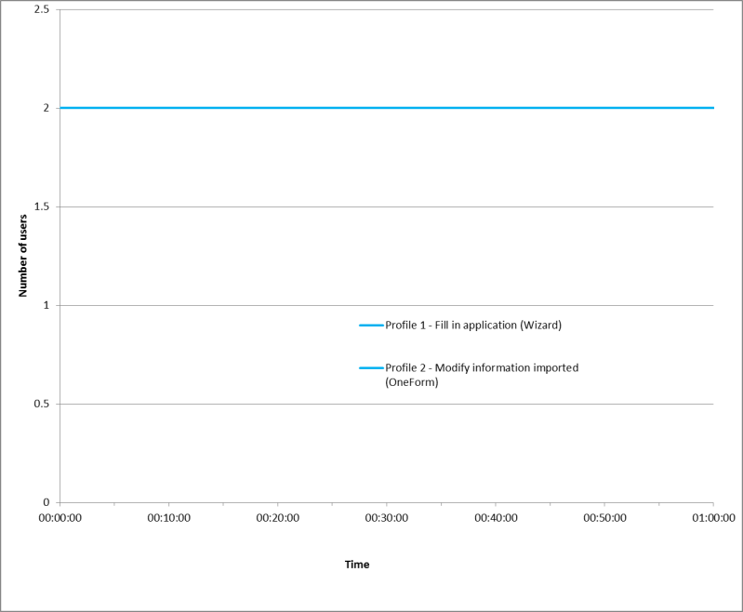

Figure 1 – Load Test Configuration

## Performance/Response Verification

The time taken to complete each step will be evaluated by using transactions in JMeter. In addition, the content of responses will be verified in order to find unexpected errors.

## Test Data

A complete and successful migration will have to be performed in order for this test to be carried out.

### Data Input

The following table shows the input data that will be used for the testing and must be taken into consideration:

| **Parameter** | **Profile/s** | **Meaning** | **Values** |
| --- | --- | --- | --- |
| language | 1-2 | Form will be filled in this language | ‘en’ (English) |
| reference | 1-2 | Reference for the design e-Filing | ‘SHADOW_USER_APPLICATION’ |
| image | 1-2 | Images of the design | images.csv |
| image_description | 1-2 | Description of your image | ‘test design image’ |
| image_size | 1-2 | Publication image size | ‘24x24’ |
| image_type | 1-2 | Type of view | ‘General view’ |
| locarno | 1-2 | Locarno of the design | ‘15’, ‘18’ |
| applicant | 1-2 | Applicant for the design | ‘11823’ |
| representative | 1-2 | Representative for the design | ‘35852’ |
| designer | 1-2 | Designer of the design | ‘1’ |
| signature_name | 1-2 | Name of the signatory | ‘Test signature’ |
| signature_capacity | 1-2 | Capacity of the signatory | ‘Applicant’ |
| current_account | 1-2 | Current account number | ‘74’ |
| import_app_id | 2 | Application Id to be imported | Data from an application filled with values above |

Table 4 - Test Input Data

The following table shows the data imported from a ‘csv' file

| **CSV file** | **Profile/s** | **Query or Data in CSV file** |
| --- | --- | --- |
| images.csv | 1-2 | Different images to be uploaded as design |

Table 5 - Data Input of the csv files

## Acceptance Criteria

No acceptance criteria described.

It is under the project staff’s responsibility to decide whether the obtained results are acceptable or not.

# Entry/Exit Criteria

## Entry Criteria

The following criteria must all be met before Performance Testing can start:

* Performance Test Approach signed off by agreed approval list.
* Test Data provided by the project staff.
* Performance Test environment available.
* Performance test tools available.
* Test preparation complete.
* Test volumetric approved.
* Test data available for all test cases.
* No known ‘Blocking’ or ‘Critical’ Jira issues with agreed exceptions.

## Exit Criteria

The following criteria must all be met before Performance Testing can be signed off:

* Actual test results meet or exceed the acceptance criteria.
* No known ‘Blocking’ or ‘Critical’ Jira issues with agreed exceptions.
* All other Priority issues outstanding as agreed by project team.
* Test Completion Report delivered.

# Test Environment and Monitoring

Apart from the transaction response time gathering via JMeter, the resource usage of the servers will be monitored.

As mentioned previously, the architecture is set in TEST environment does not mean that each office set up the same one.

The following table shows the technical specification of the servers which are involved in the test:

|  |  |  |  |  |
| --- | --- | --- | --- | --- |
| **Server Role** | **CPU** | **MEM** | **IP** | **Operating System** |
| GUI-Tomcat | 2 | 4G | 10.135.144.87 | OS Centos 6.2 |
| Services-Jboss | 2 | 4G | 10.135.144.88 | OS Centos 6.2 |

Table 6 - VMs Technical Specifications

# Risks

The following risks must be taken into consideration for this testing project:

* Test environment not available.
* Impact of other applications running on virtual machines that share the same Blade PC.

**Annex 1. Terminology**

**JMeter**: open source software designed to perform load testing and measure performance.

**Load Test**: type of testing usually carried out in order to understand the behaviour of an application at a given level of load. This load can be the number of users expected to execute or number of transactions in a given time frame. Test results give us the response-times of all critical transactions.

**Stress Test**: type of testing normally used to take the application to its functional limits, through its use by a far greater number of users than expected. Its aim is to determine the robustness of an application with an extreme load and helps administrators determine if the application will perform correctly in those circumstances.

**Stability Test**: type of testing intended to check how the system behaves long periods of load. Typically the main gaol of this kind of testing is to detect memory leaks or any other degradation condition in the servers.

**Scalability Test**: type of testing used to determine the limit of the system in terms of load. The objective is finding the “breaking point” of the system based in different conditions (maximum number of concurrent users, maximum transactions per minute, etc…)

**Ramp up Period**: lapse of time between the start of a test and the moment when the maximum user concurrency is reached (all the virtual users have started their execution).

**Full Load Period**: lapse of time between the moment when the maximum user concurrency is reached (all the virtual users have started their execution), and the end of the test.